Elementary Woodwind, Brass, and Percussion Audition Materials
Auditions for Fall 2025: All students (continuing and new) must audition for an ensemble. Students must submit audition video via Large Ensembles page on Preparatory website.
Audition materials can be submitted immediately.
Submission deadline is June 15th.
Video Requirements:
- You may submit multiple videos.
- Your video must be filmed in a single take without editing and without piano accompaniment.
- Introduce yourself at the start of your video (Full Name, Instrument)
- Performance backgrounds should be of a neutral setting. Be sure that you and your entire instrument are in the frame and properly lit so that you and the instrument are clearly visible.
- Try to achieve the best sound quality you can by finding a quiet time of day to record or a place that has minimal noise disruptions.
- Recording camera or phone should be placed on a stable surface to minimize shake and jitter.
- Please review all recordings so that your video and audio are the quality you want.
- All recordings must be uploaded as part of this application submission.
- Videos can be accepted as hyperlinks OR in the following video formats: .3g2, .3gp, .avi, .m2v,
.m4v, .mkv, .mov, .mpeg, .mpg, .mp4, .mxf, .webm, .wmv o Be sure that your video is not set to private so that it may be viewed by conductors.

Winds/Brass (and Bells)
(Flute, Oboe, Clarinet, Saxophone, French Horn, Trumpet, Trombone, Baritone, Euphonium, Tuba, and Bells)
- B-flat Concert Scale with Tonic and Dominant arpeggio (see following pages)
- B-flat Scale Etude (see following pages)
- A short solo of the student’s choice that demonstrates their current level of ability.

Percussion
- Students MUST complete the Snare Drum excerpts on the following pages (Snare Drum Excerpt #1 and #2) – see following pages.
- A short solo of the student’s choice that demonstrates their current level of ability on Snare Drum.
- Students MAY choose to also demonstrate mallet percussion by playing the B-flat Concert Scale with Tonic and Dominant Arpeggio (see following pages) AND the B-flat Concert Scale Etude. This is not mandatory, to audition for percussion, but is highly recommended.

B-flat Concert Scale (and Tonic/Dominant arpeggio)
Play the highlighted portion of the musical example below. Be sure to follow the rhythm and articulate/tongue each note.

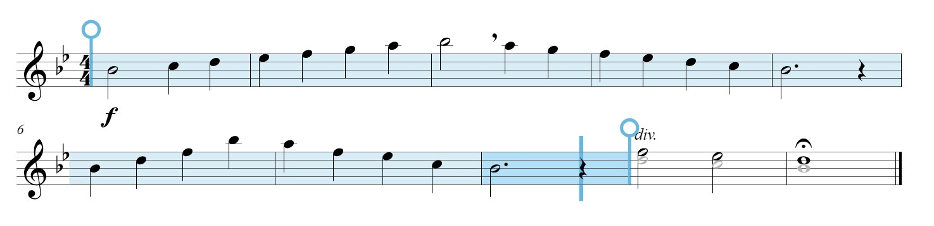
FLUTE / OBOE / BELLS CLARINET/ TRUMPET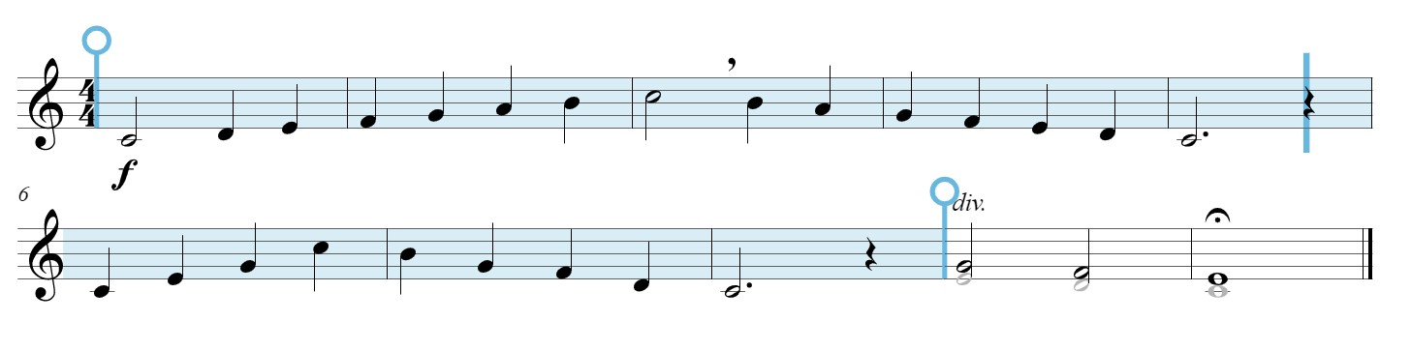

ALTO SAXOPHONE
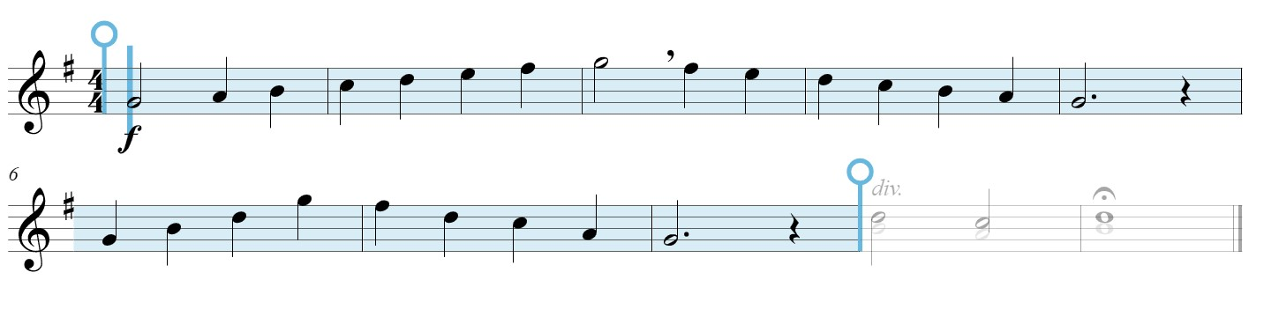

TENOR SAXOPHONE
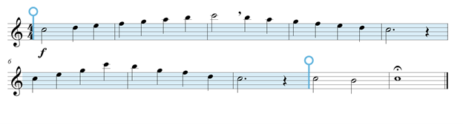

FRENCH HORN
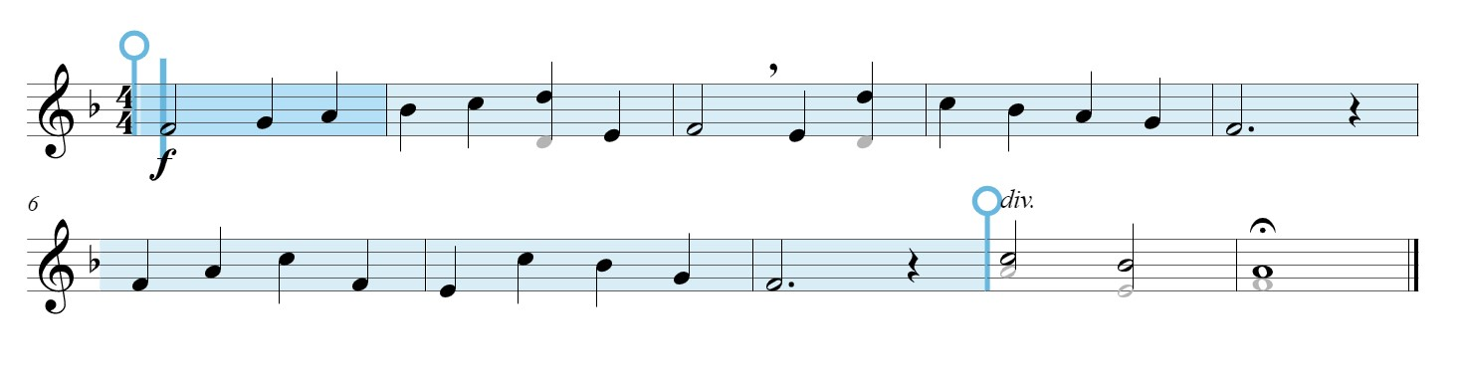

TROMBONE / BARITONE / EUPHONIUM
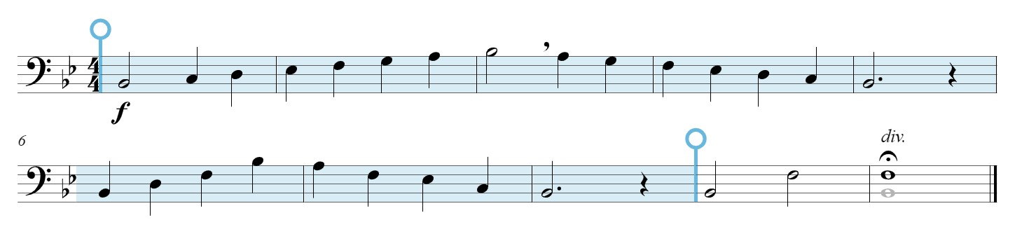

TUBA
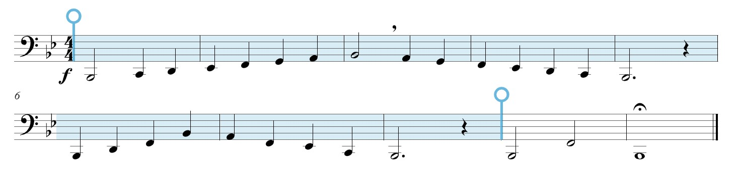

Scale Etude in B-flat

FLUTE / OBOE / BELLS
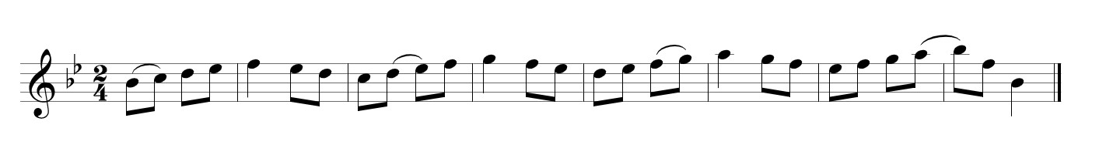

CLARINET / TRUMPET
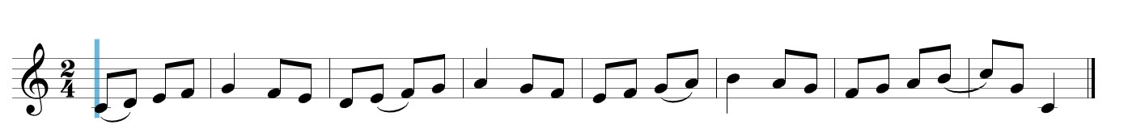

ALTO SAXOPHONE
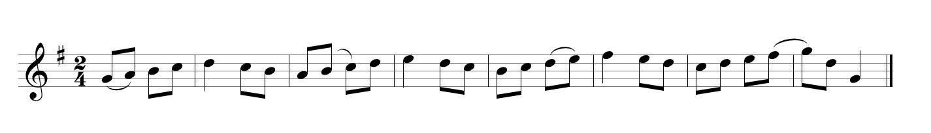

TENOR SAXOPHONE
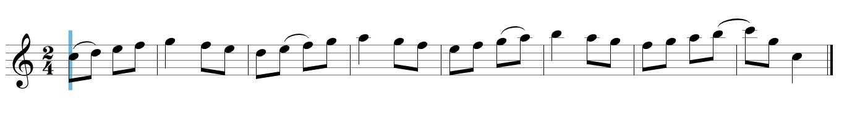

FRENCH HORN
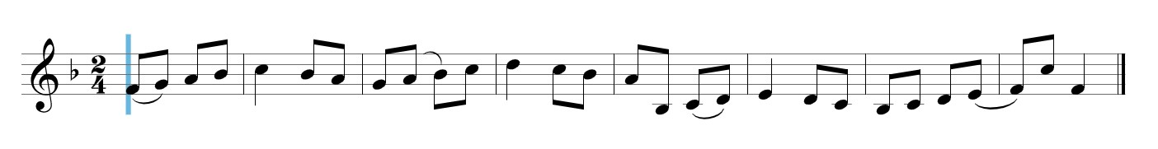

TROMBONE / BARITONE / EUPHONIUM
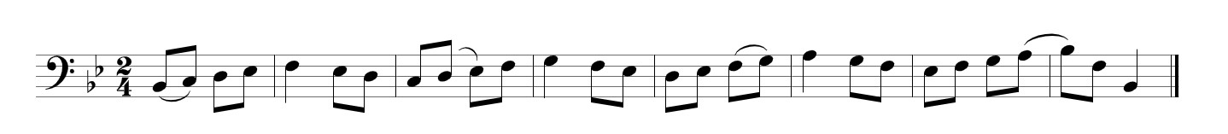

TUBA
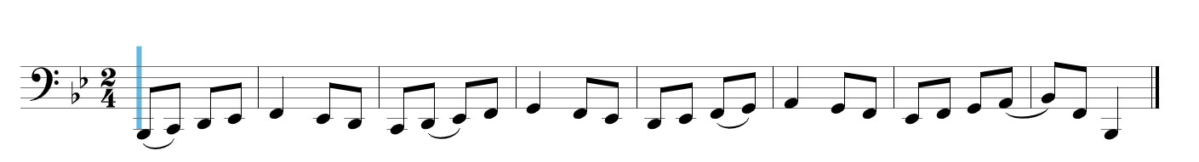

PERCUSSION REQUIREMENTS
Students MUST demonstrate the snare drum excerpts below. If the student also plays mallet percussion, they should demonstrate the B-flat Concert Scale and Scale Etude on the previous pages (for bells).

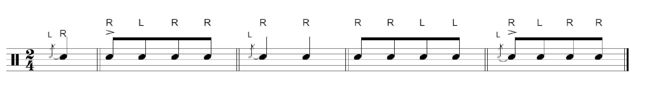
Snare Drum Excerpt #1 (play between 110 and 120 BPM)
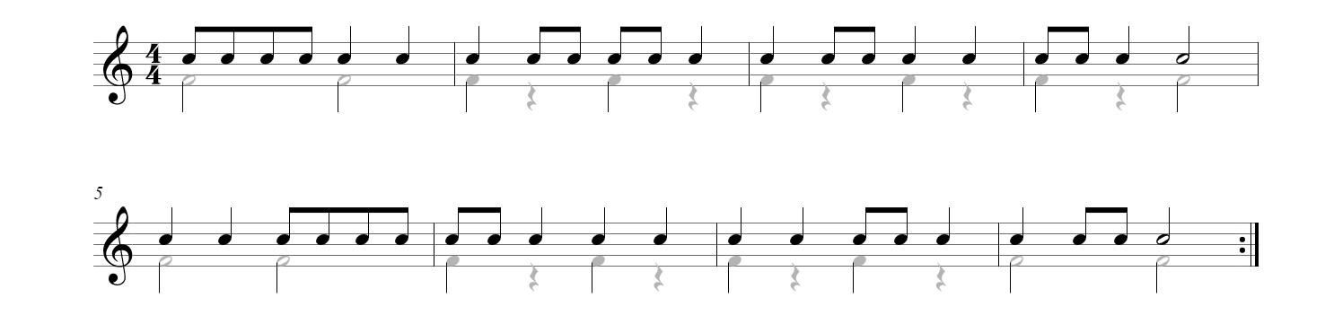

Snare Drum Excerpt #2 (play between 100 and 120 BPM)

